Code Review: I2305241
Reviewer: Mark Dell
Date: September 22nd, 2023

Bugs
- The following code uses VB6 MsgBox method instead of the .NET MessageBox.Show class and method. We have an override for the .NET version and as such, we should be using that everywhere. We really should avoid the VB6 style method anyway.
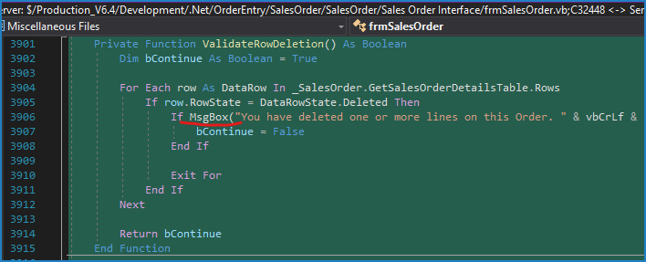

Preventative Action/Safety

Design/Architecture (Duplication, appropriate project, namespaces, maintainability)

Data Model (Naming, good design, needs index?)

Performance (Minimize DB hits, excessive loops, queries, scalable)

UI (Alignment, naming, standardization, tab order)

Error Handling (Behind events, appropriate parameter checking)

Cleanup (Dispose code, remove handlers, large data objects)

Readability (Well-named variables, methods, clear algorithm, is it understandable)

Comments (Useful, explains why rather than how)

Message Boxes (Grammar, spelling, captions, appropriate icons)

Ticket Management (Release Branch?, Testing Notes)
- Shawn’s comment on the ticket said to use our Grid Message Box functionality to display the lines that will be deleted. I see nothing that outright contradicts this in Chris’ response. I understand the idea with displaying the lines because in the old VB6 interface the delete would have occurred immediately and would have included the prompt, thus ensuring the client knew what was deleted.
This really should have been confirmed with Chris, and mentioned in the ticket, prior to making this change to eliminate this ambiguity and ensure the tester knows what should be expected. Please check with Chris as to whether this should be a simple message box (as shown in the image above), or a grid message box, and change as required.

Extras
- It is more appropriate for the business logic to interrogate the data layer, then for the form to do it. The business layer could expose a property such as “HasDeletedRows”. Note that if the logic is changed to display a Grid Message Box, then this can be ignored.

